Google Drive Download Retry
  - Design Document
Version 1.1
1/8/2026

Version History

Version Number | Implemented By | Revision Date | Approved By | Approval Date | Description of Change
1.0 | Yuri Dinh | 1/5/2026 |  |  | Initial Design
1.1 | Yuri Dinh | 1/8/2026 | Sunita Menon | 1/7/2026 | Updated after design review

Table of Contents
Version History 2
1 Introduction 3
1.1 Purpose of this document 3
1.2 Background 3
1.3 Scope 4
1.4 Assumptions 4
2 Software Design 4
2.1 Introduction 4
2.2 High-level Design 4
2.3 Detailed Design 5
2.4 User Interface Design 6
3 Database Design 7
3.1 Table Design 7

Introduction

Purpose of this document
The purpose of this document is to document the detailed design of the Google Drive download tasks retries without user reauthentication.

Background
Currently, Google Drive download tasks retires are supported through DME APIs (dataObject download retry API, collection download retry API and bulk download retry API). However, the API expects the Google Drive token upon a retry request, requiring the users to re-enter Google Drive credentials (GOOGLE_ACCESS_TOKEN). Since this forces the user to interact with the Google authentication process via GUI, we are unable to retry failed download tasks for our users. The objective is to be able to retry failed Google Drive download tasks without the need for the users to reauthenticate.

Scope
This design applies to Google Drive download tasks only and does not include retries for Google Cloud.

Assumptions
The assumption is that the GOOGLE_ACCESS_TOKEN initially supplied by the user is valid and the failure is due to unexpected network errors and not authentication errors.

Software Design

Introduction
The current retry download task APIs below supports retry of data object, collection and bulk (data object or collection list) downloads by passing the HpcDownloadRetryRequestDTO.
Retry APIs:
- POST /download/{taskId}/retry (Retry collection list or data object list task)
- POST /dataObject/download/{taskId}/retry (Retry a data file download task.)
- POST /collection/download/{taskId}/retry (Retry a collection download task)

For Google Drive download task retries, the attribute googleAccessToken needs to be supplied by the user to perform the retries.
HpcDownloadRetryRequestDTO:
{
"destinationOverwrite": true,
"googleAccessToken": "xxxxxx",
"retryUserId": "dinhys"
}

The current approach requires the user to reauthenticate and authorize DME access to their Google Drive prior to requesting the retry.

High-level Design
The following items outlines the high-level design changes necessary to support Google Drive download task retries without reauthentication.
- Make the google drive access token optional in the download retry request DTO.
- Add a DB column in the task result table to retain the google access tokens if collection, data object, or bulk download task fails.
- Retrieve the google access token retained from the DB and create the google drive download retry request.
- Introduce the retry icon in both data object and collection download task in the GUI if task has any failed items from google drive download task.
- If user doesn't perform a retry for a certain period, the google access token in the result table should be cleaned up. (New scheduler job.)

Detailed Design
The following changes/additions to the code base are required to support retries of download to Google Drive:
HpcDataTransferTypes.xsd
- Add googleDriveDownloadDestination to the complex type HpcDownloadTaskResult.
HpcDataManagement.xsd
- Add retryable Boolean to the complex type HpcDataObjectDownloadStatusDTO.
- Add retryable Boolean to the complex type HpcCollectionDownloadStatusDTO.
HpcDataDownloadDAOImpl.java
- Retrieve googleDriveDownloadDestination in downloadTaskResultRowMapper if Google Drive access token in download result table is present
- Save Google Drive access token (Encrypted) in upsertDownloadTaskResult method if token is passed.
- Add method to wipe out the Google Drive access token for tasks which failed before a configured period.
HpcDataTransferServiceImpl.java
- In completeCollectionDownloadTask, if the download task failed, save the Google Drive access token in the task results.
- In completeDataObjectDownloadTask, if the download task failed, save the Google Drive access token in the task results.
- Add a method to clean the Google Drive access token from the task result table after a configurable period. (hpc.scheduler.cron.removeGoogleAccessTokens.delay=0 0 * * * ?)
HpcDataManagementBusServiceImpl.java
- In method createDownloadRequestDTO, obtain Google Drive access token from the previous task retrieved if the user supplied HpcDownloadRetryRequestDTO accessToken is empty to submit the download retry.
- In method retryCollectionDownloadTask, obtain Google Drive access token from the previous task retrieved if the user supplied HpcDownloadRetryRequestDTO accessToken is empty to submit the download retry.
- In method retryDataObjectsOrCollectionsDownloadTask, obtain Google Drive access token from the previous task retrieved if the user supplied HpcDownloadRetryRequestDTO accessToken is empty to submit the download retry.
- In method getCollectionDownloadStatus, set the retriable flag to true if Google Drive access token is retained.
- In method getDataObjectDownloadStatus, set the retriable flag to true if Google Drive access token is retained.
HpcScheduledTaskImpl.java
- Add method removeGoogleAccessTokens to remove google access tokens retained for retries beyond the retention period.
HpcSystemBusServiceImpl.java
- Add a scheduler task to remove the Google Drive access token from the task result table after a configurable period in hours. For now, we shall set it for 1 week. (hpc.service.dataTransfer.googleAccessTokenRetentionPeriod=168)

User Interface Design
For Data Object, Collection and Collection List Download pages, the retry icon below will be added to the Google Drive Download task if any files failed in previous downloads.
The retry button will be available for a configurable amount of time while the access token is retained and disappear once the token has been removed from our system.
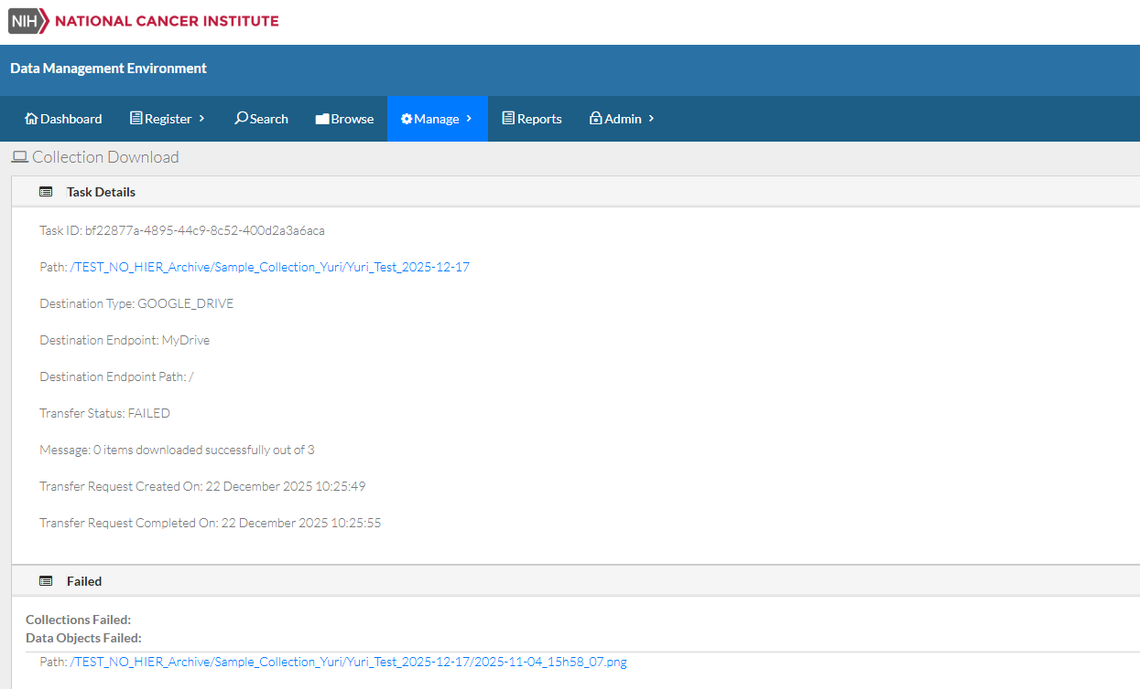

Database Design

Table Design
Add DB column, GOOGLE_DRIVE_ACCESS_TOKEN in HPC_DOWNLOAD_TASK_RESULT table.

